Business Insights on Zomato Data Analysis report

# Summary:

This document is to present key business insights / goals which can be pursued by analyzing generated Zomato analytic MS Excel report.

# Key Insights :

* Across all cities globally, **Inner City, South Africa** tops by customer ratings on overall total restaurants available in the City.
* Whereas **Bangalore** tops in receiving ‘**Excellent’** rating among other Indian Cities. Its total 9 restaurants received the high rate.

Bangalore indeed proved to be a good market for variety of cuisine consumers.

Good for future investments like partnering with new restaurants of similar cuisine type.

* Need action plan for improving average ratings for City **Faridabad, India**.
* Globally **Turky** restaurants tops among all nations on receiving better ratings and most liked cuisine found to be ‘**Kebab’** having average 4.4 rating among all Turkish restaurants.

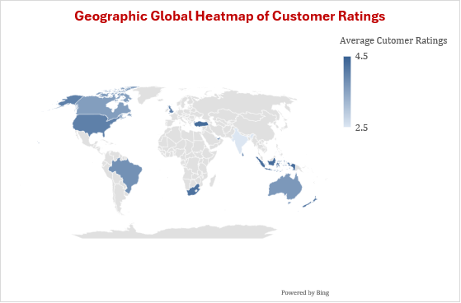

* To improve ratings in Faridabad City can be planned by partnering more restaurants providing ‘*Online Delivery’* service which has greater influence on customer engagements/preferences than ‘*Dine-in’* service